Tudor Prisoners at the Tower
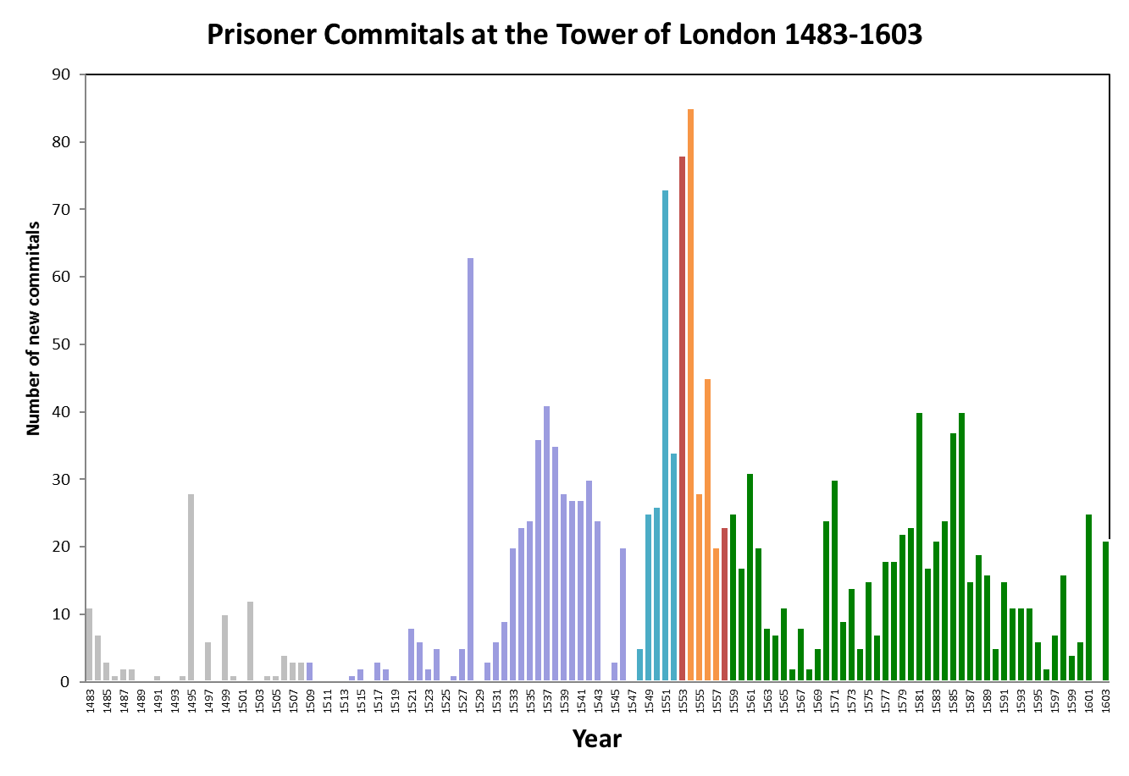
Use the graph to explore how frequently the Tower of London was used as a prison during the reign of each Tudor monarch. Why do you think there are spikes at different points on the graph?

