Front cover

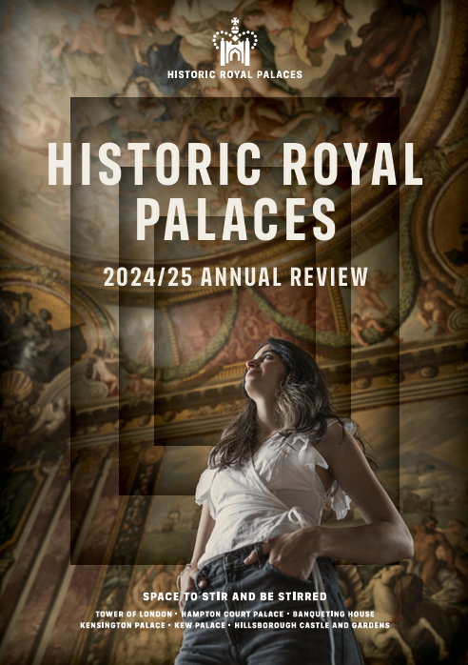

Historic Royal Palaces 2024/25 Annual Review
Contents

A joyful vision for the future: An Introduction from our Chief Executive 3
A charity for everyone 5
2024/25 Moments 6
Looking forward to our past 9
Palaces for Everyone 11
Caring for our magnificent palaces and collections 16
Experiences that tell stories 21
Writing the next chapter 26
Connections, fortified 32
Towards a greener legacy 38
Building on a strong foundation: Closing thoughts from our Chair 47
How we manage our money 49
With sincere thanks to those who make our work possible 51
Governance 63
Help give our palaces a future, for everyone 65

A joyful vision for the future: An Introduction from our Chief Executive
Recently, I was at the Chapel Royal in Hampton Court Palace, watching the Songstars programme unfold. Backed by choristers, trumpeters and a vocal animator, children from Hounslow schools began filling the chapel with song. You could feel the energy and pride vibrating through the chapel, connecting the generations, cultures and communities that were represented there.
That concert, delivered in partnership with the Choral Foundation and the Hounslow Music Service, is a reminder of why we do what we do. It points to the deeper purpose behind our work at Historic Royal Palaces: to create bold, unforgettable, heart-stirring experiences that bring people together in the most spectacular of settings. The joy in the chapel that day was palpable.
In 2024/25, we saw joy in many forms. In the thunder of hooves at the Hampton Court joust. In the creative brilliance of exhibitions like Dress Codes. In the conversations sparked by our work with schools and community groups. And in the fresh energy brought by our new apprentices who joined teams across our palaces.
It was a year of gathering momentum as we looked ahead with purpose. Our new strategy – Reach Further, Mean More, Act for the Future – called on us to be bolder and more ambitious.
We’re opening up new pathways for young people, deepening our work around accessibility and belonging, and renewing our commitment to sustainability. We don’t preserve the past for its own sake, but believe in leaving things better: more beautiful, more meaningful, and more ready for the future.
Thank you to everyone who made this year what it was – the people who visited, connected with us online and welcomed us into their communities, our partners, donors, patrons, members and, of course, our wonderful staff and volunteers.
This review is a reflection and celebration of the progress we’ve made. But more than that, it’s an invitation to come with us into what’s next.
To keep surprising. To keep connecting. To keep bringing the joy.
John Barnes CEO

A charity for everyone
  - Our mission
We are the independent charity that loves and looks after six of the most wonderful palaces in the world.
The palaces are the setting for stories that shape us all, and we’re bringing those stories to people in ways that mean more to them.
We want everyone to find themselves in the spaces and stories we share.

2024/25 Moments

Queen Charlotte wig goes on display at Kew Palace.
A costume piece from Queen Charlotte: A Bridgerton Story brought TV drama into a historic royal setting.

Tulip Festival at Hampton Court Palace.
Over 100,000 tulips burst into bloom across the historic gardens in this much-loved springtime spectacle.

Henry VIII on tour.
A research project retracing the King’s royal progresses is revealing the spectacle, politics and stories behind his Tudor travels. In Exeter, local events brought his 1539 visit to life. Delivered in collaboration with the University of York, Newcastle University and the Arts and Humanities Research Council.

Superbloom Schools returns.
25 partner schools created their own ‘moat in bloom’ gardens, inspired by the Tower’s Platinum Jubilee display. Schools received expert training, classroom resources, funding and a trip to the Tower.

Jane Seymour badge loaned to the National Portrait Gallery.
Part of the Six Lives exhibition, seen by over 67,000 visitors.

Fire: A Princess’s Guide to Burning Issues tours schools.
Our secondary schools show reached over 7,000 students across London and the East Midlands.

Peter Rabbit™ comes to Hillsborough Castle and Gardens.
A family-friendly trail brought Beatrix Potter’s beloved characters to the gardens.

Restoration in Progress.
In October 2024, we launched our first ever brand campaign, highlighting the restorative benefits of our sites and the wellbeing opportunities they offer

Relaxed Hour at the Tower launches.
A new access initiative designed for neurodivergent and learning-disabled children, offering a quieter, more welcoming Tower experience.

A-Level Study Day at Hampton Court Palace.
Students explored the world of the Tudors through expert-led talks, behind-the-scenes tours, and hands-on encounters.

Royal Style in the Making opens at Hillsborough Castle and Gardens.
This exhibition offers a behind-the-scenes look at royal fashion, revealing how designers and royal clients shaped public image through dress.

Still the Hours opens at Hampton Court Palace.
An after-hours immersive audio tour unveiling the lives of forgotten women of the palace. Developed with an inclusive dramaturg to make it as accessible as possible for blind and visually impaired audiences

Ceremonial events and royal visits.
Royal and state occasions were marked across our sites with a series of ceremonial salutes and high-profile visits. Five-gun salutes were fired at the Tower of London, including tributes for state visits from Japan and Qatar. The Tower also upheld its centuries-old traditions, from the Lord Chamberlain’s annual visit to the Ceremony of the Lilies and the Roses – an evocative tribute marking the death of Henry VI. Hillsborough Castle and Gardens welcomed six royal visits throughout the year, including HRH Princess Anne and TRH the Duke and Duchess of Gloucester. Meanwhile, Hampton Court Palace hosted TM The King and Queen for the Sustainable Markets Summit and The Queen’s Reading Room Festival.

Looking forward to our past
  - Introducing our new strategy
We want to be a charity for everyone, and we want the palaces, and their stories, to be a living resource for everyone, whoever and wherever they are. To help us achieve those aims, we’ve created a new strategy built on three pillars: Reach Further, Mean More, and Act for the Future.

Reach Further
We are on a mission to become truly inclusive and accessible. We’re working to break down barriers, to bring our work to more people than ever before, and to explore new ways of sharing the palaces and their stories, online and in person, with people across the UK.

Mean More
We want everyone to find their own meaning and connections in the stories we share, and so we create experiences everyone can enjoy on their own terms. We do this by delivering meaningful work that has a real impact on people’s lives and collaborating with communities and partners to create events and experiences that matter and mean more to them.

Act for the Future
It’s our job to preserve six historic buildings, their contents, their landscapes and their stories for future generations. So, we are committed to investing in young people: reaching every school in the UK and increasing the diversity of our sector by providing opportunities for young people to gain practical skills and experiences. And we recognise the urgent need to act in response to climate change and the loss of nature. That’s why we’re aiming to be nature positive and carbon net zero across all three emission scopes by 2050.

Palaces for Everyone
  - Opening our spaces to the public
We care for some of the world’s most extraordinary palaces, but they’re nothing without people. Each year, we open our doors to welcome millions: families, school pupils, community groups, curious first-timers and returning culture lovers alike.
These are places to be explored, felt, and remembered. From hands-on learning to world-class exhibitions and wide-reaching access schemes, we’re creating experiences that bring joy to people’s lives. We want everyone to enjoy our sites, no matter what that looks like. We’re working hard to ensure more people than ever can see themselves in our palaces, their stories, and their future.

Facts and figures
5m people welcomed through our gates
We now have over 160k members, who made just over 300k visits to our sites this year. Income from our membership generated £5.8 m, with an additional £814k through gift aid.
304k visitors to Untold Lives: A Palace at Work exhibition at Kensington Palace

Our palaces unlock a range of thoughts and emotions
“My entire life has been stories and I can see the power of storytelling… you can take these glorious buildings and make them real for children all over the world.” - Caroline Michel, Historic Royal Palaces Trustee

From surprise and discovery to a strong sense of joy, our latest visitor survey shows just how powerful a palace visit can be.
Table 1
Emotions | Percentage of total onsite visitors surveyed who agreed strongly or slightly to feeling these emotions after a visit to one of our sites
Discovery | 89%
Joy | 83%
Inspiration | 76%
Surprise | 70%
Belonging | 64%
Debate | 46%

Table shows percentage of total onsite visitors surveyed in 2024/25 who agreed strongly or slightly to the following statements: I gained a better understanding of the stories of the place (discovery); I felt happier as a result of my visit (joy); I am inspired to learn/do more as a result of my visit; I was surprised by what I saw/learned on my visit; I felt like I belonged in this type of place; and I was challenged by what I saw/learned on my visit (debate).

Improving visitor access across our palaces
Whether financial or physical, we’re working to remove the obstacles that can stand in the way of a great experience. We’re committed to opening our palaces to everyone, whether visiting in person or exploring from home.

Tackling financial barriers
To make visits more affordable, we offer £1 tickets for anyone receiving Universal Credit. This year, we welcomed nearly a quarter of a million visitors through our gates via this scheme
Making more visits feel possible
At Hampton Court Palace, we piloted deaf-led tours of the site and an audio-described tour of The Indian Army at the Palace exhibition to give blind and partially sighted visitors a more meaningful way to connect with the past. We also created new access resources, including sensory maps, and a dedicated accessibility video.
We made our experiences more accessible using digital tools. From rolling out British Sign Language tours and audio described tours on our Digital Visitor Guides (with more to come at Kensington Palace in 2026) to piloting virtual tours, we’re helping more people enjoy the magic of our palaces in new ways.
Facts and figures
£217.4k £1 tickets sold

Bringing the palace experience online
We’ve created new ways for people to connect with our palaces. Through curator-led podcasts, behind-the-scenes blogs and scroll-stopping TikToks, we’re inviting audiences to explore stories from the past in their own time and space.

We relaunched our blog and continued to grow our podcast
This year, we relaunched our Historic Royal Palaces blog, welcoming over 200,000 readers into the fascinating, surprising, and sometimes dramatic stories behind our sites. Meanwhile, our podcast series including Elizabeth I: The Women Who Shaped a Queen, reached new audiences, offering fresh perspectives on familiar figures.

We turned centuries-old stories into viral moments
We reached over 99 million people across our social media channels. Nine of our TikToks reached over 1 million views, and we experimented with new formats such as performance led videos and storytelling collaborations with curators and social media influencers.

Facts and figures
201,749 active blog users
99.5m reached through social media

What’s next?
We’re improving physical access to our palaces through commissioning access audits and making site-sensitive improvements. We’ll also be launching a relaxed events programme, deaf-led tours and access guides.
Online, we’re highlighting more under-represented stories, and introducing new expert perspectives on well-trodden narratives. We’re also rolling out more pre-visit access information such as guides and videos.

Caring for our magnificent palaces and collections
  - Now and for the future
We are the trusted guardians of wonderful historic buildings, interiors, royal treasures and precious works of art. We believe our conservation should do more than protect and preserve. It should joyfully enrich our audiences’ lives. We want to make everything in our care more beautiful, more accessible, and better prepared for future generations to enjoy.

“Britain’s royal palaces are among the most important and beloved historic sites in the world, and conserving them for generations to come is both a challenge and a great privilege. That task is not only about loving and caring for the fabric of the buildings themselves. It is also about making sure that we nurture great people with the skills required to keep the palaces the way they should be: living, working places with incredible stories to tell us all.” -Dan Jones, Historic Royal Palaces Trustee

It takes a broad range of expertise to care for the palaces and their stories. Our work includes research, managing environmental risks, cleaning, stabilisation and treatment. Our teams of specialists care for everything from wall paintings and textiles, to brick work and carpentry with minimal intervention and deep respect for the past.
Every project presents an opportunity to explore new ways for people to learn, engage, and find themselves in the spaces and stories we share. This year, we undertook projects that stretched from tiny threads of 16th-century tapestry to 10-metre-high scaffolds beneath a Baroque ceiling.

Facts and figures
Our heritage science is recognised as world-class. In 2024, we joined the UK’s RICHeS (Research Infrastructure for Conservation and Heritage Science) programme. We’re helping shape the future of conservation by sharing our data and discoveries with researchers nationwide.

Preserving a masterpiece at Banqueting House
One of the last remaining parts of the old Palace of Whitehall, Banqueting House, closed to visitors in June 2024 for a major conservation and maintenance project.
With generous support from the Garfield Weston Foundation and the Wolfson Foundation, this work is helping to protect the iconic Rubens ceiling and ensure the building’s long-term future. The project includes the installation of an air source heat pump to reduce carbon emissions and help regulate the indoor environment, which is essential for preserving this fragile painted masterpiece.
Inside the hall, we’re restoring architectural features and replacing the floor with beautiful English oak floorboards that better reflects the space’s 17th-century grandeur.
We’re also making improvements to accessibility and essential services across the site, making Banqueting House more sustainable, inclusive, and visitor-ready. The building will reopen in Autumn 2025.

Digitising the Royal Ceremonial Dress Collection
We continued a major project to digitise the Royal Ceremonial Dress Collection – a designated collection of national and international importance. It contains over 10,000 items spanning the 16th century to the present day.
These garments tell stories of fashion, life at court, ceremonial tradition, and the personal lives of some of Britain’s most iconic figures. The collection includes clothing worn by George III; Queen Victoria; Queen Elizabeth II; Princess Margaret; and Diana, Princess of Wales, alongside pieces that belonged to the people who dressed and encountered them. This project has been made possible thanks to an extremely generous legacy from Michael Stennett. As a celebrated theatre and opera designer, Michael was deeply passionate about the Royal Ceremonial Dress Collection and wanted his bequest to open the collection to a wider audience.
In partnership with Google Arts & Culture, we launched an online platform to bring together more than 200 objects from the collection, making them accessible to people worldwide, far beyond the palace walls.

Facts and figures
200 items digitised to ultra-high resolution gigapixel quality
100 additions to our collection overall

Conserving the Chapel Royal’s east wall
We assembled a specialist team of conservators, surveyors, curators, and architectural historians to conduct condition assessments and conservation work on the stunning Baroque interiors of Hampton Court Palace’s Chapel Royal.
A bespoke 10-metre scaffold enabled us to carry out essential conservation work on masterpieces by Grinling Gibbons, Thomas Highmore, and Sir James Thornhill. Visitors had the unique opportunity to observe the conservation process from the Royal Pew, offering a rare glimpse into the meticulous work involved in preserving such historic interiors. This project was made possible thanks to the generous support of The Syder Foundation and The Leche Trust.

What’s next?
This year, we launched Tomorrow’s Tower, our largest-ever fundraising campaign.
Tomorrow’s Tower will transform our facilities for school and community visits, improve accessibility and take strides towards Historic Royal Palaces’ goal of becoming nature-positive carbon net zero by 2050 – all while continuing to conserve the Tower of London for future generations and share its stories with the world.
With £1.9 million already secured in donations and pledges, we’re building powerful momentum. Support includes a development grant from The National Lottery Heritage Fund and a significant £1 million gift from the Sandys Trust.

Experiences that tell stories
  - Exhibitions, events and live programming
This year, Historic Royal Palaces continued to reimagine the events we host and exhibitions we create. In line with our new ambition, we delivered a vibrant and inclusive programme across our sites. Every element was designed to offer unique and memorable experiences for absolutely everyone. Our events have brought the palaces’ stories to life in bold and moving ways – through exhibitions shaped with communities, powerful installations and immersive experiences.

Facts and figures
28,365 visitors cheered on Henry VIII’s Joust. Fearless knights, royal drama, and high octane horseback action brought Tudor thrills to life at Hampton Court Palace.

Bringing The Tudor World to life in the Wolsey Rooms
Set in Hampton Court Palace’s oldest surviving rooms – once home to glittering opulence and political intrigue – The Tudor World explores the early years of Henry VIII’s reign and the lives of the ordinary men and women who helped shape the Tudor dynasty, through extraordinary 16th-century artworks, objects, and interactive displays designed with accessibility at their heart.
Visitors can meet Anne Harris, Henry VIII’s laundry woman, who washed his ulcer bandages, negotiated pay rises, and was later gifted a house. They can also discover the story of Jacques Francis, a free-diver from West Africa who salvaged guns from the Mary Rose and became one of the first Black voices recorded in an English court. Through rare objects and striking artworks, the exhibition traces a period of immense change. Highlights include a gold ring believed to have belonged to the Boleyn family, Thomas Wolsey’s own portable sundial and a brightly coloured silk hat linked to Henry VIII. Three rarely-seen Tudor paintings on loan from His Majesty The King add drama and detail to the Tudor court’s global ambitions.
The redevelopment of the Wolsey Rooms was generously supported by the DCMS/ Wolfson Museums and Galleries Improvement Fund.

Honouring the fallen at the Tower of London
Poppy Fields at the Tower was a poignant exploration of loss, remembrance and hope. Set within the iconic walls of the Tower of London, the powerful light installation was created in collaboration with Luxmuralis.
It offered visitors a moving space to reflect on those who lost their lives in the First and Second World Wars. The display encouraged a new way of experiencing the Tower after dark.
Archival imagery from Historic Royal Palaces, the Royal Armouries and the Fusilier Museum London was projected across the space, connecting the display to real people and stories from the Tower’s past.

What’s next?
In 2025, we’ll mark 80 years since the end of the Second World War with The Tower Remembers – a powerful new display of nearly 30,000 ceramic poppies. The installation creates a striking space for visitors to pause, reflect and remember together.
The newly refurbished Medieval Palace at the Tower of London will unveil refreshed displays and rich new storytelling. This immersive reimagining will invite visitors into the splendour of royal life, revealing how monarchs dined, dressed and ruled within these historic chambers.

Co-creating the Dress Codes exhibition with the Young Producers
For the first time, Historic Royal Palaces has collaborated with three local youth groups – City Lions, Nova New Opportunities and Harrow Club. We invited 25 young people (aged 14–17) to become Young Producers on the Dress Codes exhibition.
Working alongside curators, designers, musicians, and fashion experts, the Young Producers helped shape the exhibition’s themes and design. They created original music, poetry, fashion and digital artworks inspired by historic court dress, reimagining the Royal Ceremonial Dress Collection through their own stories and cultures.
Their creative responses are woven throughout the exhibition, including a striking green overcoat adorned with golden shells that once symbolised currency, and original music blending Afrobeat with classical sounds. This year-long collaboration demonstrates how historic dress can inspire creativity, self expression and industry pathways for the next generation. Dress Codes has been made possible thanks to the generous support of our Associate Partners, the Blavatnik Family Foundation and Avis Charles Associates.
“We really wanted to show how a collection can speak to a new generation. For us who work in these industries, it’s been refreshing, pushing us to consider new angles and stretching our creative minds to explore new ideas of what an exhibition can look and feel like.” - Matthew Storey, Curator

This is what our Young Producers had to say:
“Basically, what we’ve done is create different ways to show stories through things like video, games or poems.”

“It’s expanded my skills a lot.”

“This is the first song I’ve properly written my own music to.”

“To see so many different kinds of professionals working in one area reminds me of what I imagine a real workplace to be like.”

What’s next?
In 2026, Kensington Palace will host an exhibition to mark the 150th anniversary of Princess Sophia Duleep Singh's birth.
We’re telling her story and that of her family of remarkable royal women who expressed womanhood, power, and royalty in different ways - making us look again at what it is to be a princess. Once forgotten, they are now finding a new legacy as inspiring role models for new generations.
We are working with an intergenerational group of British South Asian women to shape the narrative and contemporary, creative response to these princesses’ lives and their legacies.

Writing the next chapter
  - How we’re reaching younger audiences

We’re passionate about inspiring young people with the power of the past, not as something distant or dusty, but as something alive and relevant.
School pupils across the UK are stepping into our stories – walking through Tudor kitchens at Hampton Court Palace during a study day, unpicking the politics of the past through debate and drama, or meeting a passionate young royal in our touring school shows.
Not every child can make the journey to one of our palaces. So, we’re going to them. Through digital resources, teacher training, and outreach workshops, we’re helping children create unforgettable experiences.

With thanks to the John Lyon’s Charity, Wol & Kerry Kolade and Richard & Harriet Taylor and a dedicated group of donors, we’re proud to launch a transformative five-year educational initiative at Kensington Palace. The Schools Enrichment Programme will foster collaborative partnerships with six local schools to broaden horizons and inspire students.

Opening doors to the past with the Schools Access Fund
Our Schools Access Fund helps break down barriers to school trips, offering free entry and inspiring, hands-on learning experiences at the Tower of London, Hampton Court Palace, Kensington Palace, and Hillsborough Castle and Gardens. For schools travelling from further afield, the fund also provides travel bursaries to make these opportunities possible.
Thanks to the travel bursaries on offer, pupils from as far away as Dundee, Wales, Yorkshire, Devon, and Cornwall have been able to take part in these unforgettable visits.
The Schools Access Fund and Travel Bursary Scheme have been fully funded through charitable donations. Historic Royal Palaces would like to thank all of our generous donors for their ongoing commitment to our work.

“I just wanted to say how much we appreciated the opportunity to visit The Tower of London and how grateful we were for the funding allocated to us. This really was a wonderful experience for all involved and our children learnt so much from the day. It was truly enriching and opened up a world that the vast majority of our children would not typically be exposed to. In a recent review of the year, all of them mentioned the trip to The Tower of London as a highlight.” - Primary School Teacher, Birmingham

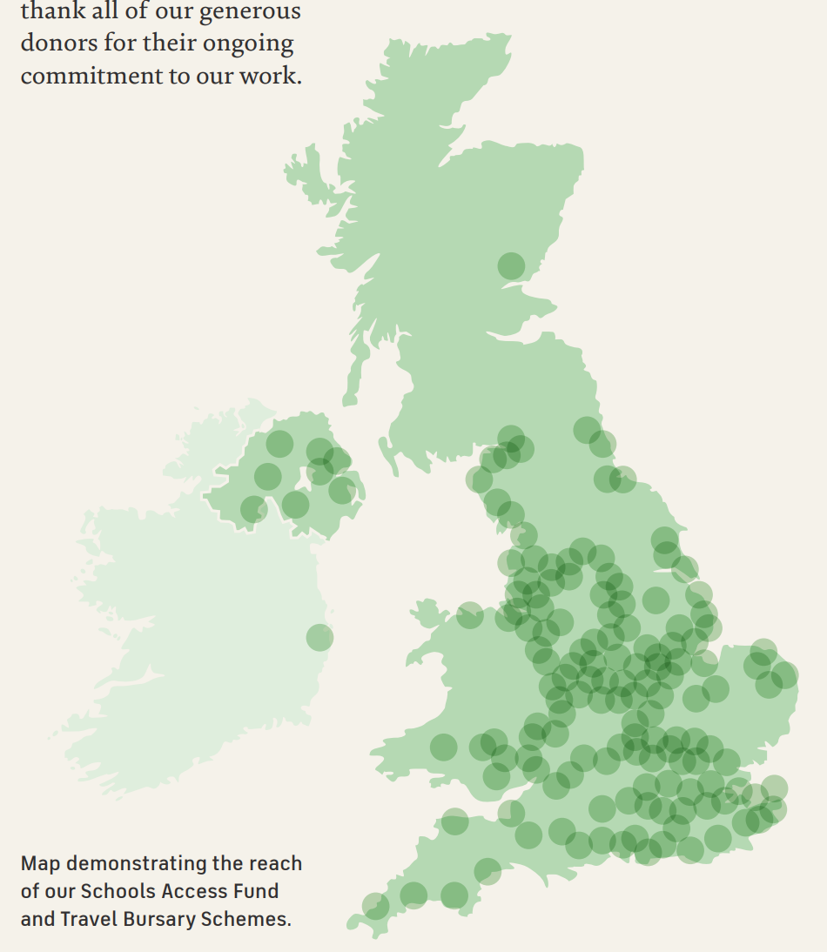

Facts and figures
Over 22k student visits funded through the Schools Access Fund and Travel Bursary Scheme

Bringing real stories into the classroom
We created new digital resources that schools can directly access. These include biographies, family trees, timelines, and a virtual tour of the Beauchamp Tower at the Tower of London. We also created films and classroom activities for Key Stage 1, inspired by significant figures from Queen Victoria to John Blanke. To help teachers bring these stories to life, we launched a new YouTube channel: Teach with Historic Royal Palaces.

What’s next?
We want to reach every school in the country in the next ten years.
To achieve this, we’re expanding our work on a number of fronts including greater outreach programmes, live broadcasting and producing more digital content.
A major focus of our Tomorrow’s Tower investment will be on creating world-class education facilities for schools and community groups at the Tower of London.

Equipping the next generation through apprenticeships
Our mission is to help everyone find themselves in the spaces and stories we share. As part of our plans, we want to remove barriers and invest in young people. This year, we relaunched our Apprenticeship Programme, bringing apprentices into roles across Historic Royal Palaces, from horticulture and conservation to law, events, and audiovisual production.
Each apprenticeship offers hands-on experience in a live working environment, paired with structured learning that leads to a nationally recognised qualification. Our programme also offers mentoring through recognised training, and peer to-peer guidance. We take pride in fostering a strong sense of community and mutual support among our apprentices and across the diverse range of standards they are undertaking. Most roles require only GCSE English and Maths, with selection based on passion, potential, and aptitude, not academic background.
The first round saw over 800 applications for just 11 new apprenticeship roles. And interest continues to grow both from external candidates and internal teams eager to host apprentices. We’ve received award nominations and secured external funding to support its future growth.
Historic Royal Palaces would like to thank The Gosling Foundation and the National Lottery Heritage Fund for their support of our Apprenticeship Programme.

“We wanted to create new entry routes to ensure that young people aren’t excluded from job opportunities in the heritage sector. I’m so excited for the future of this scheme and for the life-changing opportunities it could create.” - Jane Crowther, Historic Royal Palaces Director of Corporate Services

“Historic Royal Palaces’ working environment is optimistic, friendly, encouraging and overall, everyone shares a genuine passion for the historic palaces and visitors. An apprentice’s working day is interesting and varied meeting new people daily.” - Mia Bundfuss-Taylor, Quantity Surveyor Apprentice

“Coming in with very little experience, it has been life changing to be involved with processes and insights that were so foreign to me not long ago!” - Ricardo Paulo, Financial Planning Apprentice

“As a Building Surveyor Apprentice based at Hampton Court Palace, I’ve had the chance to work on real conservation and maintenance projects that help preserve such an iconic site. What I’ve enjoyed most is how every day brings something different and challenges me to better myself and stay proactive. The apprenticeship has deepened my interest in historic buildings and made me feel like I’m contributing to something meaningful. I’m proud to be part of Historic Royal Palaces.” - Christian Silva, Apprentice Surveyor

Connections, fortified
  - Our commitment to communities

Our palaces have always been places of gathering, celebration and story, and today, they’re no different. We believe that stories are a powerful bridge between the past and the present, between generations and cultures. These historic spaces still have the power to spark connection, joy and belonging. We work hand-in-hand with hundreds of community partners to bring our sites to life in new and meaningful ways. Our community partners often work with us to collaborate on exhibitions and experiences at our sites. Previous collaborations include The Indian Army at the Palace, co-curated with South Asian communities, and George III: The Mind Behind the Myth, shaped by men with lived experience of mental ill-health. The stories of these palaces belong to everyone.

Facts and figures
Over 45,000 afternoon teas were sold at Kensington Palace, raising £34,000 for our Community Programme through a £1 voluntary donation.
The ‘By You’ Tapestry was displayed in the Welcome Centre at the Tower of London from 14th June – 31st August 2024. This was an international community project led by Stitches in Time, one of our Community Access Scheme partners. Stitched by 190 embroiderers from across the world, the tapestry explores daily life during the pandemic.

Opening doors with the Community Access Scheme

Now in its 12th year, the Community Access Scheme (CAS) welcomes a wide range of visitors to our palaces, including local charities, mental health groups, community centres, and refugee networks. Our regular events, meet-ups, and celebrations help foster a supportive and growing community.
The scheme includes training sessions for group leaders, free tickets to our palaces, support from our team to help connect with the stories, spaces, and collections we care for, and invitations to our year-round events and gatherings.
“Fantastic and intergenerational scheme which opens a new world to those who might normally not be able to enjoy the delights of Britain’s rich and varied history. Learning Events are also very helpful for Group Leaders as you gain insights into current exhibitions which you can then share with your groups.” - CAS group leader

Facts and figures
We have 517 community access partners
29,000 people visited our palaces through CAS

Making memories with Amazing Days Out
For many, a visit to our palaces remains out of reach. The Amazing Days Out programme works to remove barriers and support children and their families to have a joyful, memory-making day out.
We’ve helped low-income families, single parents, young carers, children in clinical settings, and those with special educational needs and disabilities. We also work with early years groups, looked-after children, and families who are newly arrived in the UK, including refugees. We run this programme year round across the Tower of London, Hampton Court Palace, Kensington Palace, and Hillsborough Castle and Gardens, working in partnership with a host of organisations.
Our aim is to help visitors build confidence, connection, and a sense of belonging, so they return again and again. The programme includes free tickets to our palaces, support in planning a visit, access to our learning spaces, facilitated activities, light refreshments and more. Alongside regular visits, we also host special moments such as our Christmas at Kensington events.
“I attended a special community group’s visit to Kensington Palace with my friend and her two children, one of whom has complex needs. I genuinely nearly cried, that this wonderful little boy had found a moment to engage with the exhibition, on his own terms, in his own way, in an environment in which, in many places, he would not have been welcome. This event engaged individuals for whom the barriers normally presented are too much and demonstrates that they are welcome, valued and included.” - Amazing Days Out visitor response

Some of our amazing days our partners include:
- Achieving for Children
- Home-Start
- Gingerbread
- Hackney Virtual School
- Sparklers
- Venture Centre
- Solace
- Bracknell Mockingbird
- Parent Skills to Go

Facts and figures
812 visitors visited our palaces through the Amazing Days Out programme

Creating Warm and Welcome Spaces at Kensington Palace
Launched in partnership with the health and social care charity Turning Point, Warm and Welcome Space invites local people to experience the palace in a different way. Held weekly in the Clore Learning Centre, it provides a safe, supportive environment for anyone who needs warmth, connection, and community.
The sessions create space for informal conversations with people who might not usually visit our palaces or see them as places for them. This helps us better understand local needs and shape more inclusive, responsive programmes.
Visitors can take part in yoga and fitness classes, mindfulness sessions, games, crafts, and receive practical advice. Over the past year, we’ve connected with 957 people. We’ve watched them grow in confidence, discover new skills, and begin to feel a real sense of ownership and connection to our palaces and their stories.
“What’s amazing is that this project is open to all, not just Turning Point clients. Everybody just joins in as one big happy family. There’s no judgment. No boundaries. No barriers or anything like that.” - Daniel Floyd, Turning Point Manager

Facts and figures
Over £1,000 raised by staff and community partners through our Five Palaces Walk
We provide over 250 hours of drop-in sessions annually

What’s next?
We aim to develop our Amazing Days Out by supporting statutory holiday activities and food programmes across London, helping us reach more people.

Towards a greener legacy
  - Our approach to sustainability

We act not just for those who currently experience our sites, but also for those in the future. That means addressing our impact on climate change and nature loss and ensuring our buildings, collections, and teams are resilient to the challenges already upon us.
2024/25 marks the first full year of our Sustainability Action Plan and the starting point on our journey to nature-positive carbon net zero. The UK is one of the most nature-depleted countries in the world and, as custodians of around 1,000 acres of protected parkland, gardens and outdoor spaces, we take our responsibility to conserve and improve the biodiversity in our care seriously.

Progress against our targets
82% of our staff are aware of our Sustainability Action Plan and 51% are clear in their role in delivering it against a target of 75%.
We've reduced our energy consumption by 24% against our 2019 baseline, we’re aiming to achieve a 40% reduction by 2035.
In 2024/25 45% of our electricity came from REGO (Renewable Energy Guarantees of Origin) backed sources. We’re aiming to get to 100%.
By autumn 2025 we’ll have met our target to have a full emissions baseline for scopes 1, 2 and 3.
“ Since joining the Historic Royal Palaces Trustee body I have been hugely proud of the commitment of the whole organisation to better understanding the impact of our sites and work in terms of carbon, and then putting that knowledge to great effect holistically to reduce our carbon footprint and ensure the estate is more environmentally, socially and financially sustainable for the next generation.” - Camilla Finlay, Historic Royal Palaces Trustee

Greener gardens at Hampton Court Palace
This year, we began an ambitious redesign of the Great Fountain Garden at Hampton Court Palace. Our focus is on enhancing soil health, boosting biodiversity, and building climate resilience while preserving the garden’s historic character.
Much of the current planting is cultivated in the on-site nursery, which is one of the largest consumers of gas across the estate. By rethinking the planting approach, this project aims to reduce reliance on glasshouses and help lower carbon emissions.
We’re proud to be partnering with award-winning garden designer Ann-Marie Powell to bring this vision to life.
“Sustainability is at the core of my approach in designing garden habitats that invite an evolving ecology, and I’m looking forward to collaborating with Historic Royal Palaces and their talented gardening team to reimagine the Great Fountain Garden. Together, we will honour the garden’s rich history by promoting sustainable gardening practices that ensure it can continue to thrive in the face of future environmental challenges.” - Ann-Marie Powell

Total emissions and breakdown
Our total carbon emissions for 2024/25 were 3,643 tonnes of CO2e – a 21% decrease compared to our 2019 baseline. Emissions from heating and electricity (Scopes 1 and 2) have fallen by 31%, mainly through improved management of our buildings and improved efficiency of building fabric and systems. Our largest source of direct emissions remains our gas consumption, used primarily for heating our buildings. We’re working hard to deliver plans to electrify our heating systems and equip our buildings for the future. In 2024/25 45% of our electricity came from sources backed by Renewable Energy Guarantees of Origin (REGOs). We’ve already increased this to 88% for 2025/26 and are working towards 100% by 2027.

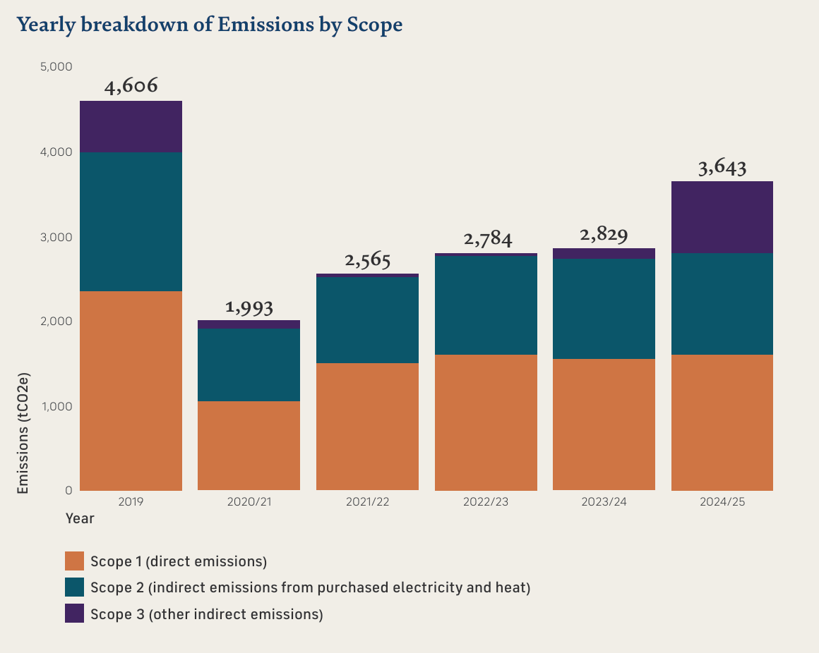
Yearly breakdown of emissions by scope
2024/25 Emissions by Scope (market based)
Table 2
Scope | Sum of Emissions (tCO2e)
1 | 1,624
2 | 139
3 | 654

Energy Consumption at each of our sites
Table 3
Site | Consumption (GWh)
Hampton Court Palace | 5.37 GWh
Tower of London | 5.01 GWh
Hillsborough Castle and Gardens | 2.44 GWh
Kensington Palace | 0.95 GWh
Stafford Cross Retail Distribution Centre | 0.17 GWh
Kew Gardens | 0.12 GWh
Banqueting House | 0.03 GWh
Thames Ditton | 0.02 GWh

Facts and Figures
Total emissions (market based) – 2,417 tCO2e
We’ve reduced our electricity consumption by 1.5 GWh since 2019. That’s the equivalent of 48 million cups of tea!

What’s next?
Reducing these emissions is the focus of our decarbonisation programme and we'll be tackling some of our biggest users in the next five years.

Like-for-Like emissions and intensity
One of the central goals of our Sustainability Action Plan was to enhance the consistency and quality of our emissions data collection. During the 2024/25 reporting period, we made significant strides – expanding the range of emission sources and improving the type of data gathered. As a result, our reported emissions increased by 30% compared to 2023/24, largely driven by Scope 3 emissions. This rise reflects the inclusion of waste data from our three largest sites, more accurate tracking of business travel, and better reporting of fuel and energy-related activities. We remain committed to refining our tools and deepening our understanding, enabling us to strengthen our reporting processes and focus our efforts where they can have the greatest impact.
The table below shows our like-for-like position compared to 2023/24 with any additional data sets removed for a clearer view of our progress year on year.
Table 4
Emissions (tCO2e) | 2024-2025  (Like-for-Like) | 2023-2024  (Like-for-Like) | Percentage Change
Scope 1 | 1,597 | 1,549 | 3%
Scope 2 | 1,118 | 1,151 | -3%
Scope 3 | 200 | 129 | 55%
Total | 2,915 | 2,829 | 3%

Facts and Figures
0.86 kgCO2e per visitor vs. 0.97 kgCO2e in 2019

Experimenting with the State Apartments
We are conducting experiments with the Round Kitchen Court heating system at Hampton Court Palace. This system heats most of the State Apartments and visitor routes in the palace and is home to some of our most significant interiors and collections. The tests we ran included:
- Reducing the operational temperature from 78°C to 73°C, with tweaks to Building Management Systems logic to adjust based on outside temperature and reverse this change if needed.
- Turning off each heating circuit between 23:30 – 00:30 to save consumption, while monitoring environmental impacts using Environmental Management loggers around the palace.
These efforts have resulted in up to 13% savings in gas consumption, and 16% when normalised for temperature. This is the equivalent of nearly 150,000 kWh or 28 tonnes of carbon.

Laying the groundwork for a better future
2024/25 laid important foundations for our sustainability ambitions, with strong progress made across the year and more to come. In 2025/26 we’re continuing to develop our plans for decarbonisation, waste reduction and water management. We’re also developing a new internal learning framework to give teams across Historic Royal Palaces the tools and confidence to embed sustainable thinking into their day to-day roles.

Decarbonisation Programme
We're continuing to develop our plans for decarbonising some of our largest gas consumers with projects at the Tower of London, Hampton Court Palace, and Hillsborough Castle and Gardens.

Climate risk and adaptation
We're continuing to develop our knowledge of the future climate risks to our palaces and working with expert partners to create adaptation plans to protect them.

Supporting Nature
Throughout 2025 we’ve been gathering more information about the condition of our natural estate and are beginning to develop plans to support biodiversity even better in the future.

Learning framework
We’re developing a new internal learning framework to give teams across Historic Royal Palaces the tools and confidence to embed sustainable thinking in their day-to-day roles.

Sustainability Champions Network
We are strengthening our Sustainability Champions Network to increase its reach and impact

Building on a strong foundation: Closing thoughts from our Chair
To my amazement, I find I have been Chair of Historic Royal Palaces for almost two years. And, like a benevolent godfather to six remarkable children, I am continually amazed by the distinct personalities and accomplishments of our palaces.
The eldest child, the Tower of London, looks sprightly thanks to expert conservation. The glorious Tudor and Baroque Hampton Court Palace has a lively schedule of festivals. Whitehall's Banqueting House has a fresh elegance thanks to new Exmoor oak floorboards. Kew Palace offers idyllic quietude, while Kensington Palace has welcomed record audiences. Our youngest family member, Hillsborough Castle and Gardens in Northern Ireland, charms with beautiful gardens and a stunning art collection.
We're firing on all cylinders. Our renovations include repairs to the Tower of London; Kensington Palace's east facade; the roof of the Mantegna Gallery; Hampton Court Palace's chimneys; the interior of Banqueting House; and archaeology at St Peter ad Vincula, the chapel at the Tower. Then there are our conservation projects of tapestries, uniforms, costumes, and paintings – not to mention sustainability projects designed to safeguard our outdoor spaces.
And our ambition continues to grow. We're opening the palaces to new visitors, including those from less advantaged backgrounds. Our most ambitious fundraising target ever will help us repair and reconfigure parts of the Tower. We aim to be carbon neutral by 2050. And we want to double the number of schoolchildren visiting the Tower, inspiring the next generation to embrace our history.
The six palaces in our care are among the UK's most important historical landmarks. Can you think of more crucial buildings in our island’s story than the Tower of London or Hampton Court Palace? I certainly can’t. So, our Board of Trustees and Executive Team feel our responsibility most acutely, because the palaces’ place in history is priceless.

Sir Nicholas Coleridge, CBE DL, Chair

How we manage our money
  - Our 2024/25 financial summary
We are a charity whose work is made possible thanks to income generated through admissions, commercial activities, and the generosity of our donors, patrons, members, and sponsors.
This year, we’ve made significant commitments to expand our charitable work, investing in major building projects whilst maintaining a focus on the care of our palaces, collections, and gardens. From welcoming 4.2 million visitors, to hosting palace-takeover events, reopening the Orangery at Kensington Palace, and launching our most ambitious fundraising campaign to date at the Tower of London, our income-generating activities have been instrumental in driving forward our expanding ambitions throughout 2024-25.
As we look to the future, we will invest more than ever before in our major projects and conservation programmes, and we will continue to push further with our unwavering commitment to being nature positive carbon net zero by 2050.

Total Income
- Donations, grants and membership – 8%
- Admissions – 61%
- Commercial Income – 26%
- Investments and other income – 5%

How income was used in 2024/25
- Caring for our palaces, collections and gardens – 24%
- Interpretation and education – 12%
- Opening the palaces to the public – 20%
- In year projects – 4%
- Future project investment – 21%
- Organisational development and income generation – 19%

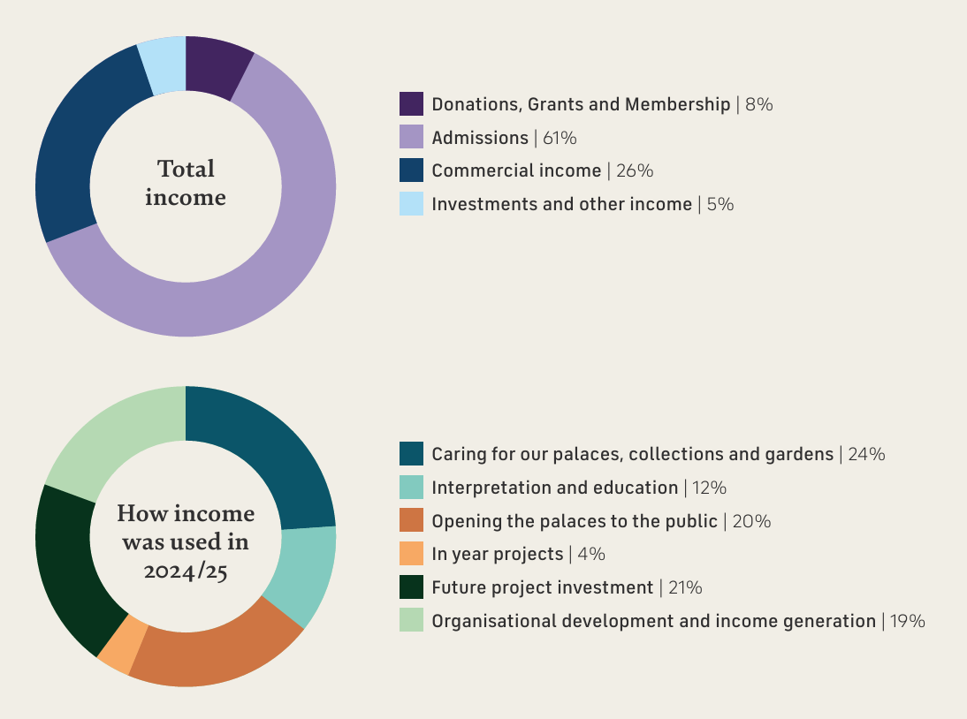

For our full annual report and accounts, please visit the Historic Royal Palaces website.

With sincere thanks to those who make our work possible
  - We couldn’t do it without you
We’re incredibly grateful to all those who support our work. As an independent charity, Historic Royal Palaces receives no regular funding from the Government. Everything we do is made possible by our visitors, members, donors, legacy pledgers and patrons. Your generous support helps us care for six extraordinary places and bring their stories to life for everyone, now and for the future.
We would especially like to thank the following donors and patrons, as well as those who have chosen to remain anonymous.

King’s Presence Chamber
The Court Leadership Circle
3i
The Cadogan Charity
The Clore Duffield Foundation
Garrard
The Gosling Foundation
The National Lottery Heritage Fund
Mark Pigott KBE KStJ
Royal Salute
The Sandys Trust
Garfield Weston Foundation
The Wolfson Foundation

Platinum Key Holders
The Foyle Foundation
Mrs Aud Jebsen
The Star Family Foundation

Gold Key Holders
Bloomberg L.P
City of London Corporation
J Paul Getty Jnr Charitable Trust
The Hobson Charity
Marsh McLennan
Mitsubishi Electric Europe B.V.
The Eranda Rothschild Foundation

Silver Key Holders
The Art Fund
Graham & Joanna Barker
Blavatnik Family Foundation
Boundless by CSMA
The Bradbury Foundation
Bruce & Jane Carnegie-Brown
The BGS Cayzer Charitable Trust
The Clothworkers’ Foundation
Coates & Seely
The Worshipful Company of Drapers
William & Olga Fall
Herbert & Ellen Kozlov
John Lyon’s Charity
Charles Mackay CBE & Annmarie
Mackay
Serrie & Ian Meakins
The Anthony and Elizabeth Mellows Charitable Settlement
The Rothermere Foundation
Mr & Mrs Peter Smedvig
Robert & Patricia Swannell
Michael Uren Foundation
The Charles Wolfson Charitable Trust
The Lord Leonard and Lady Estelle
Wolfson Foundation

Bronze Key Holders
The Apollo Foundation
Backstage Trust
Ian Barlow DL & Judy Barlow
Benefact Group
Kate Birch & Dominic Christian
Duke of Buccleuch & Queensberry, K.T., and the Trustees of the Buccleuch Chattels Trust
Constance Cincotta
Dr Martin & Dani Clarke
The Clasper Family
The John S Cohen Foundation
Susan Cook
David Cruickshank
Professor Mallory Factor KCNG & Elizabeth Factor Esq.
The Fishmongers’ Company
The Getty Foundation
Alderman Alison Gowman CBE
John Harding MBE
The Charles Hayward Foundation
Peggy Hui
Wol & Kerry Kolade
The Mallinckrodt Foundation
Charles & Nicky Manby
Dr & Mrs Allen Sanginés-Krause
The Schroder Foundation
Nick Segal & Genevieve Muinzer
Swire Charitable Trust
The Syder Foundation
Richard & Harriet Taylor
M. Louise Wilson FRSA
The William Brake Foundation
The KT Wong Foundation
WRA Charitable Trust

Honorary Members
Michael Day
CVO Angela Heylin OBE LVO

Corporate Members
Bloomberg L.P
Boundless by CSMA
John Lewis Partnership
Lazard
Marsh McLennan
Mitsubishi Electric Europe B.V.
Syracuse University London
The Comets, Metropolitan Police Sports and Social Association
The Mitre Hotel, Hampton Court
The Royal Mint
Walpole

Corporate Sponsors and Donors
3i – Learning & Engagement programmes
Findmypast – Untold Lives
Garrard – Jewel House representation
Mitsubishi Electric Europe – Schools Access Fund
Optio Group – Moat in Bloom and Superbloom Schools
Royal Salute – Gun Salutes and Martin Tower whisky experience space

In-kind support
Coates & Seely

Ambassadors
Professor Sir David Cannadine FBA FRSL FSA FRHistS FRSA
William Fall
Sir Rupert Gavin
Charles Mackay CBE
Dr Lucy Worsley OBE
Robert Swannell CBE

Patrons
Council Chamber
Susan Cook
John Harding MBE
Serrie & Ian Meakins
Donna Ockenden Limited
Mr & Mrs P Rowland

Great Watching Chamber
Gary & Andree Allsopp
Nicola Andrews
Kate Birch & Dominic Christian
Peter & Diana Butler
Dr Martin & Dani Clarke
Mr & Mrs Anthony Hall
Christian & Dawn Hill
Simon & Glenda Weil
Suzanne Marriott
Mrs Jane E Miller
Elizabeth Sallis
Sarah Selkirk
Chad Stride & William Parsons
Debbie & Edward Speed
Phil & Caroline Swallow
WRA Charitable Trust

Great Hall
Annabel Asprey
Andrew Hine
Lucinda Holmes
Geoff Low
Malcolm Lowe
Valerie & Philip Marsden MBE
Nick Segal & Genevieve Muinzer
Lynne & Mark Rickabaugh
Nicholas & Amanda Wachsmuth Heavens

Courtyards & Cloisters
Steve & Claire Almond
Barry Adamson
E and S Andrews-Fisher
Mark & Priscilla Austen
Ian & Judy Barlow
John Barnes OBE
James Bicknell
Dr & Mrs Stuart Blackie
Marie-Louise Bradley
Jennifer Pearl Cate
Lady Chadlington
Andrew & Joanne Chamberlain
Claudio Chittaro
Chloe Cooper
Anthony Dinkin KC
Charlotte Fletcher
Anupam Ganguli
Charles & Dawn Garland
Mr & Mrs P. Geddes
Anne Herd
Jacqueline Isard
Florence Kipling
Julia Kirkham
Mr & Mrs Alan Lovell
James McDonald
The Melville Charitable Trust
Mrs Diana Midmer
Mark & Jude Mladek
John Moore
Antonia Newman
Richard Oldfield
Helen Polito
Lady June Powell
Beverley Robb
Dean Rowell
Mr & Mrs Kevin Smith
Michael Smith
Carole Souter CBE
Bill Toner
Bryan Whatling

Honorary Patrons
Todd Longstaffe-Gowan
Alison Weir

And those that wish to remain anonymous

Campaign Board
Jonathan Bewes (Chair)
Lucy Asprey
Pim Baxter OBE
Alison Bishop
Elizabeth Campbell
David Cruickshank
Professor Mallory Factor KCNG
Lucinda Holmes
Carol Leonard
Suzanne Marriott
General Sir Gordon Messenger, KCB DSO* OBE DL
Rak Patel
Richard Taylor
Trelawny Williams
M. Louise Wilson FRSA

Historic Royal Palaces Inc. Board of Directors
Herbert F. Kozlov (Chair)
Monica Gerard-Sharp (Vice Chair)
Professor Sir David Cannadine FBA FRSL FSA FRHistS FRSA
Ji Young Choi
Edward Carl Albin Forsberg, Jr
James C. McCarroll
Genevieve Muinzer
Antonia Newman (Ex-Officio Director)

Historic Royal Palaces Inc. Patrons
Sapphire
Michael J. Brown
Ji Young Choi
Deborah Dorshimer
Natalie Pray MBE

Ruby
Ramesh Bhimsingh
James Gordy
Brian Abel Ragen
George & Patti White
Christine Wong

And those that wish to remain anonymous

Hillsborough Castle and Gardens Board of Directors
Sir Nicholas Coleridge CBE DL (Interim Chair)
Devon C. Bruce
James Clerkin
Nicholas Hill, 9th Marquess of Downshire
Edward Guinness, 4th Earl of Iveagh
Geoffrey Hemphill
David J Mills
Dr Leonard O'Hagan CBE DL FIOD
Breege O'Donaghue
Sir John Parker GBE FRENG
James L. Sintros
Julie Sinnamon
Sue Wilkinson OBE

Governance
Our governance structure is robust in ensuring delivery of our strategy, operational plans, and compliance with our policies, but also agile enough to help us meet emerging challenges and make the most of new opportunities.

Non-executive: Oversight of strategy, policy, plans and compliance
Board of Trustees
Sir Nicholas Coleridge CBE DL (Chair)
Jonathan Bewes (from 1 Oct 2024)
Lisa Burger CBE
James Chalmers (from 1 Jan 2025)
William Fall (until 14 Apr 2025)
Camilla Finlay Tom Harris (from 15 Apr 2025)
Sarah Jenkins
Dan Jones (from 15 Apr 2025)
Tim Knox FSA
General Sir Gordon Messenger KCB DSO* OBE DL
Dame Caroline Michel (from 15 Apr 2025)
Sir Michael Stevens KCVO (until 31 Dec 2024)
Dr Jo Twist OBE
Sue Wilkinson OBE (until 30 Apr 2024)
Professor Michael Wood OBE (until 10 Mar 2025)

Standing Committees
- Audit, Risk and Assurance
- People
- Nominations and Governance
- Finance and Investment

We also have working groups focused on our charitable objectives and major projects

Executive: Development and delivery of strategy, policy and organisational plans
Chief Executive
Executive Team

“It’s an exciting and important time to be a Trustee of Historic Royal Palaces. There is an ambitious new strategy to deliver, a substantial programme of events and exhibitions to oversee, and a forward-looking educational and sustainable agenda which will position us strongly for decades to come. And to top it all, it is great fun to be delivering this with my impressive and like-minded colleagues on the Board!” - General Sir Gordon Messenger, KCB DSO* OBE DL, Historic Royal Palaces Trustee

Help give our palaces a future, for everyone
  - Everything we do is made possible by people like you
We’re on a mission to reach further, mean more, and act for the future and we’d love you to join us. Whether you're passionate about conservation, education or community events, there are lots of ways you can offer your support.
How to get involved:

Become a member
Enjoy unlimited entry, exclusive events and behind-the-scenes content, all while helping us care for these extraordinary places.

Make a donation
Every gift, big or small, helps us protect these remarkable places and share them with more people.

Leave a gift in your will
A legacy gift helps ensure these palaces – and the stories they hold – will be here for generations to come. It’s a lasting way to support the things you care about most.
Volunteer with us
Looking for a meaningful way to give your time, develop new skills, and connect more deeply with the stories that shape our past and future? Then consider becoming a volunteer and help to continue the fascinating stories of our palaces.

Become a patron
Becoming a patron is one of the most meaningful and fun ways to get involved with our work. Not only will you enjoy a close relationship with the charity, but also exclusive experiences and privileged access to the areas of the palaces not open to the public.

Partner with us
From corporate sponsorship to charitable partnerships, we work with organisations of all sizes to create purposeful relationships that make an impact.

For further information on how you can be part of Historic Royal Palaces, please contact our Development team at development@hrp.org.uk

Back cover

Contact us
Email: info@hrp.org.uk
Tel: 0333 320 6000

Acknowledgements
Text © Historic Royal Palaces 2025
Unless otherwise indicated, all images are © Historic Royal Palaces
This annual review was designed and produced by Historic Royal Palaces.

All rights reserved. No part of this publication may be reproduced, transmitted or stored in an information retrieval system in any form or by any means, electronic or mechanical, including photocopying and recording, without prior written permission from Historic Royal Palaces.

Historic Royal Palaces is a Registered Charity (No 1068852)

