Teacher Resource

Elizabeth I and the

Great Debasement

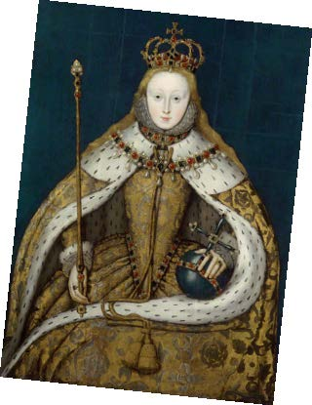
Classroom Activity

This activity supports:
Elizabeth I: How did she tackle the problems of her reign?

Learning objectives:
- Evaluate Elizabeth I’s decisions and effectiveness as a monarch.
- Analyse Elizabeth I’s response to the crisis caused by the debasement of England’s coinage.
- Investigate what caused Elizabeth I’s currency troubles and how they affected the economy and society.

You will need:
- PowerPoint projector or interactive whiteboard.
- Print outs of card sort activity (included with this resource)

Suggestions for use
Pupils step into the role of the Queen’s advisers in this activity. They help Elizabeth I analyse, understand and respond to the currency troubles facing England in 1560.

A card-sort activity and decision-making task are included in the PowerPoint resource.

Use this activity to:
- Introduce or brainstorm some of the aims or qualities a monarch might want (for example, to appear strong and powerful). You may also consider the monarch’s responsibilities such as the economy, military, religious policy etc.
- Ask pupils to sort, analyse and prioritise evidence and information about the crisis facing Elizabeth I in 1560.
- Explain aspects of Elizabethan society during the queen’s reign to help contextualise the pupils’ research.
- Ask pupils to write (or give orally) a report describing England’s currency problems and an analysis of what caused them.
- Ask pupils to work in teams in the decision-making activity as they consider the pros and cons of each possible response to a range of dilemmas faced by Elizabeth I during the crisis. Pupils learn how closely their advice matches against the Queen’s decisions and actions (could be adapted into a game).
- Encourage pupils to reflect on what they have learned about Elizabeth I’s reign and her qualities as a monarch, including her effectiveness in dealing with the problems caused by the Great Debasement.

